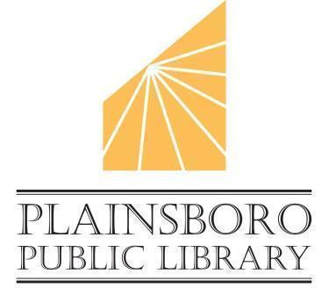
TRUSTEES OF THE FREE PUBLIC LIBRARY OF PLAINSBORO

LIBRARY HISTORY ROOM

6/3/2025 AT 7:00 P.M. BOARD MEETING

AGENDA

- Announcement of Compliance with Open Public Meeting Act and Call to Order

- Announcement of Public Comment Sign-In

- Executive Session - Personnel Matters
- * Approval of May 2025 Minutes
- *Approval of May 2025 Executive Session Minutes

- Treasurer’s Report

- * Approval of May 2025 Bills and Signing of Checks

- Foundation Report

- Director’s Report

- Old Business --

- New Business -- *PSEG Energy Efficiency Refit

- Public Comment

* Board Action Required; Above is the agenda as known at the time of posting this notice. In case of inclement weather, contact director@plainsborolibrary.org for access to a virtual meeting.

